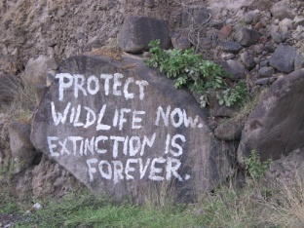
9 James Lane, Goodwill, Tel: 1 767 440 3835
P O Box 456, ROSEAU, Website: www.eccea.org
Commonwealth of Dominica, East Caribbean.
24th January, 2011

Ambassador Ichiro Fujisaki
Embassy of Japan
2520 Massachusetts Ave, NW
Washington, DC 20008-2869
Tel: (202) 238-6700
Fax: (202) 328-2187
Email: jicc@ws.mofa.go.jp
Web page: http://ws.mofa.go.jp/
Dear Ambassador,
Greetings,
The East Caribbean Coalition for Environmental Awareness is an umbrella organization with its membership scattered throughout the East Caribbean, and with international affiliates.
It is with regrets that we write bringing to your attention the fervor with which many people denounce the position taken by your Fisheries Ministry with regards to whaling in the Southern Ocean Whale Sanctuary.
We all live in a shared world that comprise a legacy of land and sea, and we expect the international agreements that protect that legacy to be observed in order to engender peace, goodwill and sustainability. It is therefore with grave concern that we observe your government's continuing defiance of agreements of the International Whaling Commission, by whaling in the Southern Ocean Whale Sanctuary.
Even more alarming is the fact that you have responded to peaceful objection by dispatching armed coast guards to do battle with unarmed protestors at sea. Is that not overplaying your hand against people who feel it is their right to protect international agreements? Please note that your government will be held morally and legally responsible for any lives or limbs that may be lost due to this aggressive move.
One Californian man who did a 25 day fast to draw attention to this issue had the following to say, " ...If necessary I will join the countless individuals who have given their lives for two fundamental principles:
* The rule of law must prevail, and
* Armed aggression on the high seas is unacceptable ...."
These are some of the reasons why we petition you in the first instance to recall your armed men, and secondly, to observe these international treaties that impact positively on the global legacies of humankind.

Respectfully,
East Caribbean Coalition for Environmental Awareness (ECCEA)

(Sgd.) Mona George-Dill,
President, ECCEA,
Email: monageorge@cwdom.dm
Cell: 1 767 277 1377

